**ASSESSMENT 1: PROJECT DELIVERY**

**NAME:** MOHAMMED ZHOEB

**STUDENT ID:** 00287693T

**SUBJECT:** MIS606 Professional Practice

**LECTURER:** DR MAHBUB AHMED, PhD

CONTENTS

List of Abbreviations 3

List of Acronyms 3

List of Tables 3

List of Illustrations 3

List of Annex 3

List of Keywords 4

Abstract 5

1) Introduction 5

1.1 Background 5

1.2 Problem Statement 5

1.3 Research Questions 6

1.4 Limitations 6

1.5 Scope 7

1.6 Significance 7

2) Literature Review 9

3) Research Methodology 20

3.1 Data Collection Method 20

3.2 Data Analysis Method 23

3.3 Research Process 26

4) Analysis 27

5) Findings 27

6) Recommendations 27

7) Conclusion 28

References 29

**List of abbreviations:**

API: Application program interface

AWS: Amazon Web Services

MS-DOS: Microsoft Disk Operating System

POSIX: Portable Operating Interface

RDS: Relational Database Systems

SQL: Structure Query Language

SSD: Solid State Driven

HTTP: Hypertext Transfer Protocol

**List of Acronyms:**

API, AWS, MS-DOS, POSIX, RDS, SQL, SSD, HTTP

**List of Tables:**

Table 1.1 – Person Entry

Table 1.2 – Feedback

Table 1.3 – Total Data Reports

Table 1.4 – Total registers and usage

Table 1.5 – Transactions

Table 2.0 – Analysis Data

**List of illustrations:**

Fig 1.0 Executive mode classification (Sutton, 2017)

Fig 1.1 User Mode Classifications (Sutton, 2017)

Fig 1.2 EFTPOS AS-IS

Fig 1.3 EFTPOS (TO-BE)

Fig 1.4 Data Collection Method (Paradis & O'Brien, 2016).

**List of keywords:**

Cloud migration

AWS cloud

Modernization

Internet Information Services Server

Distributed Component object model

SWOT Analysis

HAL (Haskell)

Abstract:

Modernization is a key to the most of the companies in maintaining their application to cope up with the market demands. As most of the companies are moving towards cloud computing which provides better features than the on premises server serving at its best. The report below discuss about the migration of the EFTPOS application to the AWS cloud which provides data safety, efficiency in cost and flexibility to the users in a big organization like Myer. Various methods of data collection were used in this report to collect the data and were analyzed using SWOT analysis which serves as main basis for the application migration to cloud.

**1. Introduction:**

**1.1 Background statement:**

Myer one of the largest retail brands of Australia operating in all the states of the country with around 60 stores with headquarters located in Melbourne. It was founded by Sidney Myer along with his brother in the year 1900 with their first store in Bendigo ("MYER", 2020). The stores are found to be busier during the busy season of Christmas in the month of November and December as well as on the Boxing Day.

In (2019) the company faced a serious issue on the Boxing Day whereas the eftpos machine crashed across all the stores of the country making a chaos among the buyers. The reason for the Eftpos failure was because of the usage of the single on premises server used by each store. Due to more flow of data packets from both the ends made server crash.

**1.2 Problem statement:**

Does the movement of the system from single on premises server to the cloud can solve the issue which is also called as modernization. Does modernization provide any issues in the future?

Issues and difficulties faced by the store user in accessing the current applications in EFTPOS and also inconvenience caused to the customer with the delay.

Using 5 W approaches in providing the problem statement explanation for root cause analysis:

WHO – Who is affected by the problem?

It affects the company revenue generation due to the slow processing limited functionalities due to the outdated application and also it affects the customer making them spend more time in the billing process by standing in queues.

WHAT – What is the actual issue?

The actual issue for this particular problem is due to the leveraging of the old application which is already in the end of life support, old technology and devices used across for all the transactions within the stores.

WHEN – When does the issue occur?

The issue occurs during the peak period of sales where the customer load is high and usage of EFTPOS machines increases with the load, which results in downtime, failure of the application.

WHERE – Where does the issue occur?

The occurrence of the issue happens in the EFTPOS machines where multiple store applications are used for performing store and customer transaction.

WHY – Why it is important to fix the issue?

It is important to fix the issue as it will increase the revenue generation by attending to more customers within the limited period of time.

**1.3 Research question:** As most of the organization in today’s world is moving in a way of modernization where companies are shifting their application to the cloud. Based on the organization type which cloud would be better? What tools can be used to build the application in the cloud?

**1.4 Limitations of Windows server 2003:**

**The main reason to overcome from windows 2003 server was because of the following reason:**

**Compliance issue:** Most of the countries have a set of regulations that company systems have to meet certain regulatory compliance requirements. Due to lack of maintenance support provided by the Microsoft to the windows 2003 server it falls out of the compliance category.

**Security issue:** Due to end of the extended and mainstream support by the Microsoft more security defense patches cannot be fixed due to the incompatibility of the server to the new fixes or patches. Defense in depth (DiD) is one of the security update that cannot be made compatible with server 2003 which failed to get implemented on it.

**Cost:** Most of the reports suggest that maintaining the system which is outdated found to be 1.6 times more costly than buying a new server and its new software especially for small and medium sized companies. Getting a new hardware along with its new software is found to be more cost effective (Morris, 2016).

**1.5 Scope:**

Cloud migration has been initiated as a part of store modernization, considering the key objective to increase the process speed along with advanced functionalities. This migration might bring flexibility, cost efficiency and speed to the application that is been expected to be completed by the end of the fourth quarter of this year. As the project holds a constrain of hardware as the store will be using the existing EFTPOS registers with latest applications in it which might limit few functionalities. Providing a statement of work to the key stakeholder who includes all the contents and the entire scope of the project and obtaining their approval for the same.

**1.6 Significance of the AWS cloud over the windows server 2003:**

**Protecting data:** For industries cloud plays important role for transferring sensitive data in and out by authorized use of the environment which can be carried out proficiently without any much restrictions. AWS maintain data safety by using the safety protocols and processes which include data encryption, storing data with the user data encryption key, avoiding sensitive data in logs and cache, real time encryption and decryption key etc.

**Access to the cloud resources:** AWS allows regulatory access management making the cloud secure for the user to use the cloud resources like S3 storage. AWS Dynamo etc.

**In compliance with regulations:** Everyday inspection has to be done to need the meets of compliance rather than at the time of audits and inspection. The business risk can be minimized by following the authorization and managing session to prove the compliance. The compliance should consist of policy of strong password, session tokens for login, two way authentication, timeout for the session that are inactive, CAPTCHA use at time of registration etc.

**Flexibility:** Cloud utilization provides more flexibility to the users as it is web enabled and employees can access data through any means of devices such as smartphones, notebooks etc. upscale and downscale of the existing resources permits the business to accommodate along with its requirement enabling the business development without much system change. This act as an important factor for most of the business to move to the cloud.

**Backend and platform services are secured in the environment:** It allows the customer to sustain within the protected environment by paying for the services that are utilized deprived from the cost and expenditures of on prem servers. It consist of well protected APIs at the backend, data allocation is secured in between the web server and cloud, monitoring and maintaining the server logs, having access control for the platform of cloud.

**Productivity increase:** Software installation is not much needed in the cloud as most of them is been automated and maintained by the Amazon team, making the users to have access from any part of the system into the platform. Based on the recent surveys it was found that company acclimatized to the cloud has good revenue growth.

**Scalability growth:** On premises server are hard to maintain its software and hardware whereas in comparison to on cloud everything resides on the internet which enhances the scalability. It supports auto scaling of Dynamo DB, Lambda tools for cost coverage of the services that are been used only and not for the services that resides backend making more cost efficient to the company.

**Piracy restricted:** Most of the companies strive to mitigate the threat for piracy to avoid data loss. AWS possess various security process and controls solving risk and thread mitigations (Mukherjee, 2019).

**2.** **Literature Review:**

**Architecture of windows server 2003:**

The functions of the server are been differentiated into two modes: executive mode and user mode.

**Executive mode:** It is an operating system that controls the system data and services including the hardware interfaces that are been handled by the executive mode.

**User mode:** The user mode usually handles the applications which are subjected to UI including optional subsystems. User mode interacts with the hardware and system through an API which is highly integrated.

**Executive mode:**

The operations within the executive mode are been segmented into five operations running in the privileged mode. All the elements are been distinguished from the user mode. Any information can be updated or deleted as they are completely independent from the user mode. The various segments of executive mode include:

1. **Hardware layer of abstraction:** This layer is mostly present at the base of the architect where all the code related to interfaces is been present ensuring great portability across the platforms. This layer usually deals with the issues which are device dependent and CPU with Intel compatibility. HAL synchronized with all the hardware threads and ranges the priorities with higher to lower.
2. **Microkernel:**

It is a non-configurable segment of the server which can never be modified or recompiled. The system usually controls and dispatches various threads. Controller usually manages the thread profiles, address process which are present virtually and interrupts. Whereas dispatcher synchronize and implements events, threads, timers etc.

1. **Device drivers:**

It acts as a middle medium of instructions compiling the operating system along with the hardware like modems, printers, cameras, scanner etc. The burden of maintaining multiple drivers by system administer was been reduced by deploying the windows server.

1. **Executive manager:**

It is a cluster of various applications which allow the executive mode and user mode to have an access to system resources. The various executive managers include the following:

**Object manager** manages the files, processes, threads etc.

**Memory manager virtual** allocates the bit linear memory; it also expands its memory on hard drive.

**Process manager** manages the thread and other related process

**Inter process communication** manages the local and remote call procedure.

**Security referencing monitor** operates in both the modes giving access which gives an access to object.

**Input and output manager** controls both the input and output functions.

**Graphic drivers and windows manager** have been moved to the executive mode in 2003 server making application communicate directly with the system interface and HAL.

**Play and plug manager** adds the devices automatically using the hardware.

**Cache** helps to fetch the data from disk to memory monitoring the startup of the application.

**Configuration** maintains the system between the registry settings and executive mode. It increases the functionality and has a security role.

**Power** segment manager regulates the power flow to the computers allowing the server to maintain automatically by itself.

1. **Service buffer:** It is a layer of small code between executive and user mode acting as medium for API and system call.

**Executive mode:**

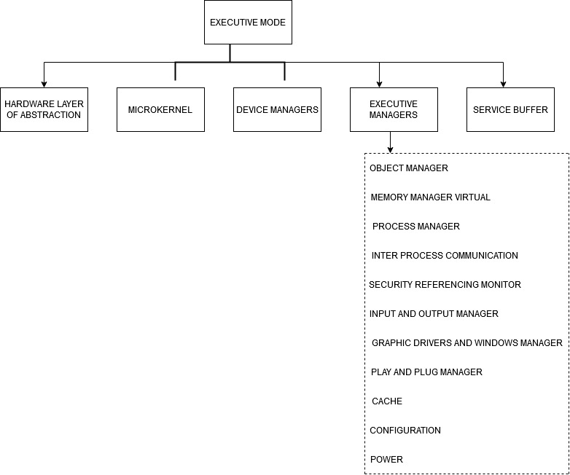

**Fig 1.0 Executive mode classification (Sutton, 2017)**

**User mode:**

To facilitate the integrity of the application and user, all the components of the user has to work together. The user mode consists of two parts:

**Environmental protected subsystems**: This part of subsystem holds the specific requirements of windows (MS-DOS), OS/2 and POSIX applications.

**Dynamic user intervention**: unprotected actions of the user is been overseen by this part.

The protected subsystem that is present between the user application and executive mode cannot be changed or altered by the user which is configured by APIs and other utilities. The two protected subsystems supported by windows 2003 includes:

**Integral:** This part of subsystem usually supports the task of security management. For example providing logon request, authentication and monitoring the resources use.

**Environmental:** This part of subsystem supports the applications which are written for other operating system. It has a wide range of supporting platform from the applications to different programming APIs. It consists of subsystem Win32 controlling graphical UI. Win32 applications can be made to run within this subsystem (Sutton, 2017).

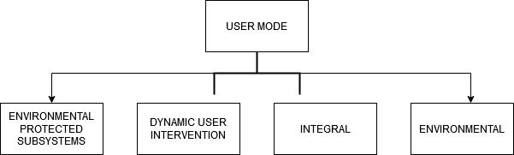

**Fig 1.1 User Mode Classifications (Sutton, 2017)**

**Amazon web services architecture:**

**Networking and compute:**

Compute elastic cloud: It provides the changeable compute capacity within the cloud which is mostly used by the administrators and developers.

Scaling automatically: It provides the compute instance scaling automatically to perform better performance during heavy traffic time and decreases when the demand is less.

Load balancing: It distributes the incoming data flow across the various compute instances and detects the unhealthy instance and reroutes the traffic to the healthy instance unless the unhealthy instance is restored.

Workspaces: It is a desktop managed computing service within the cloud allowing the customers to access data with the device of their own choice.

Private cloud: It is a separate section present within the web services where the user has the access to configure the IP address of known range, gateways etc which can be customized quickly.

Direct connect: It has direct network connectivity to the AWS from the user desired environment decreasing the cost of connectivity and increasing the network bandwidth.

**Storage and delivery network:**

S3: It provides the simple service interface which can store or retrieve data at any time and place. Providing safe, reliable secure and fast data to the user.

Glacier: It is low cost service for storage of data highly optimized for the data which is not used frequently taking several hours to retrieve the data.

Elastic block storage: It provides storage at block levels for use of compute instances of elastic cloud. Suited for the applications that require file based system or database.

Gateway of storage: It provides the service for connecting IT environment of on-premises server to AWS cloud. So that data can be store securely and can be cost effective.

Export/import: This service provides data flow in and out of the system using high speed internal network and internet bypass.

Cloud front: It provides services such as integration of all the web services ensuring the developers and business easy content distribution.

**Database:**

Relational database: AWS provides easy operate and scale RDS in cloud. Giving access to MySQL, SQL, and Oracle database.

Dynamo: It is a cost effective database which do not use the SQL to store or retrieve data. It stores data on SSDs (solid state drives).

Elasti-cache: This service make easy to operate, deploy cache present in memory in cloud.

Redshift: It is a cost effective DB which can be used by our own existing business intelligence tools.

**Analytics:**

Kinesis: This service provides processing of data at massive scale. Extreme amount of data can be processed within hours allowing easy writing of the applications useful in marketing and financial environments.

Pipeline of data: It is a service that provides the data move from compute to storage service at specific time intervals.

**Application services:**

Application streaming: It a service provides streaming of the application from the cloud to the devices like games. It helps in rendering the application to AWS and stream output to user on various devices.

SQS: It is a service that queues the message decoding the components within the cloud application.

Notification service: It provides easy message service on the devices

Workflow: It provides fewer instances for writing code and invests on logic within the business to make applications more different and unique.

Email service: Cost effective service for bulk email sending to developers and organization.

Cloud search: It provides quick search for various files, information, web pages etc. easy to search and manage solutions for the applications.

**Management and deployment:**

Access and identity management: It provides secure control on the access of the users. It helps to create users keys, passwords etc. for resource access.

Cloud watch: It helps to monitor the resources and application run by the customers present on the cloud tracking the metrics and insight gain to keep application function properly.

Beanstalk: It is a service helps to deploy the web applications that have been built on various languages like .NET, Java, Python etc. balancing and scaling automatically once the application has been uploaded.

OpsWork: It is a management service enabling users who are Devops modeling the complete application from balancer to databases (Mathew, 2020).

Lambda: lambda helps in functionality of the code without managing the servers. The code has to be uploaded only once and there is no need to pay when the code is not running. It provides the code with high level of availability

**Eftpos Architecture of Windows Server 2003 (As – Is):**

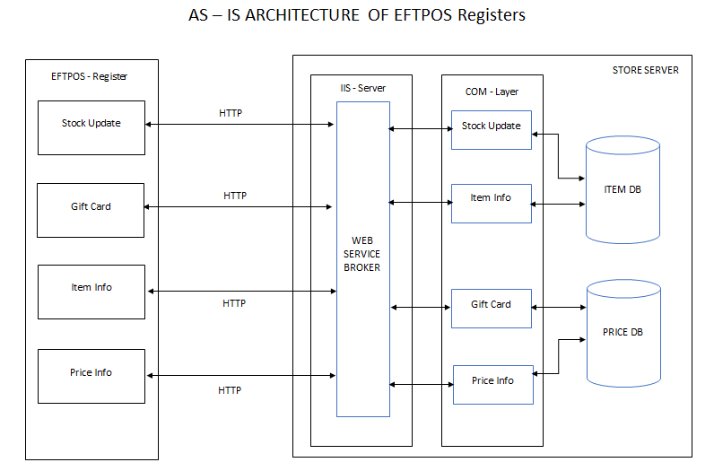

**Fig 1.2 EFTPOS AS-IS**

**Register (Eftpos):**

The Eftpos register usually consist of four applications which include stock update, gift card, item information and price information.

Stock update: This application makes a registry of the stock present in the stock and the number of items sold.

Gift card: The Company provides different varieties of gift card across various stores around the country. These cards can add a discount onto the total price of the purchase.

Item information: This application gives information about the product like its size, price, availability etc. As every item has a bar code and number they are been updated into the product registry and they can be replaced or purchased at any store.

Price information: Price information application gives information about the price of the product present at that time which might also be subjected to change because of various season sales.

HTTP is from the register is send to the server requesting for the data from the server itself. HTTP stands for the Hypertext Transfer Protocol, it sends request to the web server requesting for granting the permission for accessing the data. Most of the secret information like card numbers or confidential data is been done by using this protocol (Okumura & Ogata, 2020).

**Internet Information Services Server (IIS Server):**

It acts as a layer between the clients and the data base of the server. It was developed by Microsoft which servers the requested HTTP request for the data for sharing between the clients and web server. To run multiple sites on the IIS server the sites has to have different IP address, port number and Hostname. It supports various activities like outlook, share point etc. (Thomas, 2020).

The request from the Eftpos register is been transferred to the COM (component object model) through IIS web server. Where the information is been processed further.

**Component object model (COM server):**

Component object model is been developed by the Microsoft which uses the binary software components to build an application which can be executed in the environment of the windows. This provides the interface between the DCOM and objects and severs as the basis for various Microsoft technologies (Kumar & Mall, 2017).

Each application of the Eftpos register has separate component in the COM server.

**Database:**

**Item data base:** The information regarding the item and stock is been stored in the item data base.

**Price database:** The information regarding price and gift card is been stored in price database.

**Eftpos Architecture of AWS Cloud (To – Be):**

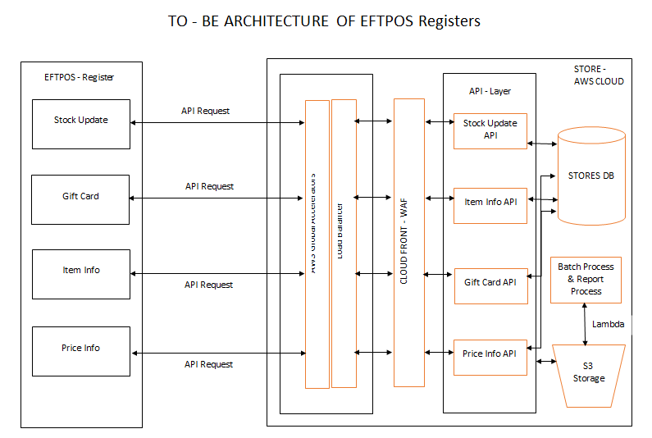

**Fig 1.3 EFTPOS (TO-BE)**

**Users Register:** The different applications from the user register which include stock update, gift card, item information; price information sends the **API** to the AWS cloud server.

**API** is a set of source which is predefined provided by the application to expose the data or the services. By using these sources the applications can access the other data and services without implementation of procedures and object which are underlying. These are used for most of the modern architectures (Meng & Steinhardt, 2018).

**Global accelerator:** The API traffic from the register is been send to the global accelerator of the AWS cloud. Global accelerator is the networking services which direct the traffic flow to web services architecture improvising the user experience.

It enhances the latency of the applications by directing the traffic flow to available zones to avoid the packet loss during the spike.

It also protects the application by providing shield from DDoS attack and AWS uses private IP address ("AWS Global Accelerator - Amazon Web Services", 2020).

**Load Balancer:** The data flow from the global accelerator is received by the load balancer. As the load balancer detects the unhealthy instances to be recovered it can prevent the system from being crash or delayed enhancing the performance. As it automatically balances the traffic flow it makes the application highly available, secure and using selected IP address can provide flexibility to the application ("Elastic Load Balancing - Amazon Web Services", 2020).

**Proxy Server:** It acts as an intermediate between the application of the client and the application of the server (AWS). Using the proxy server the traffic data can be monitored and filtered and it also serves as caching (Kurniadi, 2015).

**Cloud Front:** All the services from the various components of the AWS can be integrated in the cloud front. Easy distribution of the content can be done between business and the clients (Mathew, 2020). The cloud front provides faster performance and has the availability throughout global. It provides the high security guarded by the AWS shield at low cost.

**API server:**

The flow of data takes place towards the API server where each application has its own component of API application within the server. The flow of data from the API server is been stored in the database of the amazon cloud.

**Database:**

The relational database is used in AWS cloud for this application. As relational database reduces the redundancy of data for this application, and maintains the integrity of data.

**Lambda:**

Lambda function in AWS is used for processing batch jobs and report functionalities for the application.

**S3 Storage:**

AWS cloud provide the storage within the cloud in the S3 bucket, where all the application related files can be stored for the longer duration of time, and all the logs files with respect to.

**3. RESEARCH METHOD:**

**3.1 DATA COLLECTION METHODS:**

Data collection is a method of collecting information in a systematic process which answers the question of research. In this method the quality of evidence is collected which is then transferred to data analysis to build a logical answer with strong evidences to the research question.

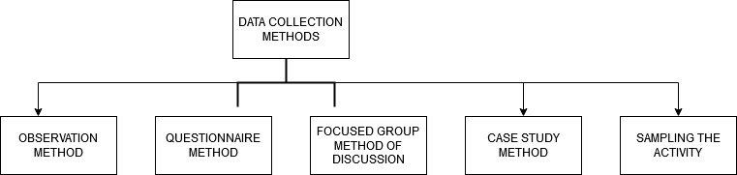

**Fig 1.4 Data Collection Method (Paradis & O'Brien, 2016).**

**Observation method:** According to the (Stenhouse,1975) observation is been defined as a systematic enquiry which is made public. Observation has to be selective in order to be systematic firstly and secondly the information that has been collected has to be interpreted and analyzed in order to make the observation public. Most of the researchers made the observation naturally or some using some tools called as scientific observation using machines (Paradis & O'Brien, 2016).

**Case scenario:** In this method of data collection the organization has used the device called people counter which counts the inflow and outflow of the customers within the store each day. This helps the organization to collect the data about the customer flow and number of customers visiting each day to the store.

**Sample Data:**

|  |  |
| --- | --- |
| **People entry** |  |
| 1600 Person | On foot entrance |

**Table 1.1 Person Entries**

**Questionnaire method:** It is one of the qualitative method of data collection where surveys are been conducted to collect the information. Surveys are ideal for data collection documenting the perspective, knowledge and analyzing with various techniques (Paradis & O'Brien, 2016).

**Case scenario:**  In this method, survey forms were been given to the customers who have shopped in the store to know their shopping experience within the store. Online feedback has also been extracted and the data was been analyzed.

**Sample Data:**

**Survey Questions:**

|  |  |  |  |
| --- | --- | --- | --- |
| **Survey question** | **Excellent** | **Good** | **Bad** |
| Shopping experience | Highly received feedback |  |  |
| Customer service | Highly received feedback |  |  |
| Customer billing experience |  | With suggestion on time consumed for billing process and the product scanning response in Registers. |  |
| Areas of improvement |  | Most of them was on EFTPOS waiting time |  |

**Table 1.2 Feedback**

**Focused group method of discussion:** In this method a group of people is been interviewed to know their underlying attitudes, opinions, information and to study the social dynamics of the group. This method is mostly used to discuss the sensitive topics, exploring new area of research and gathering the data which is preliminary (Sajjad Kabir, 2016).

**Case scenario:** Retail operation teams had a multiple brain storming sessions based on the data gathered for each application such as stock update, gift card, item info and price info. Data with respect to each of the application was gathered from front end as well as the back end and many loop holes were identified in the current application along with huge manual interventions, which can be replaced by an automated process.

**Sample Data:**

**Stock Update, Gift card, Item Info & Price Info Application:** Data reports of all the time consumed for the stock taking activity for each store.

|  |  |
| --- | --- |
| **Data reports** |  |
| Total brands | 50 |
| Items scanned | 12000 |
| Time for stockupdate | 8 hr |
| Time for giftscan | 6hr |
| Time for item info | 8hr |
| Time for price info | 5hr |

**Table 1.3 total data reports**

Manual effort: 30 member staff across the entire store at the registers, scanning the required items.

Consumption time and the manual effort can be reduced by enhancing the applications.

**Case study method:**  In this method the investigations are made in an event or group and data is been collected from various sources employing different techniques. Case study involves the researcher to observe the group or event and investigating in much depth (Sajjad Kabir, 2016).

**Case scenario:**  The event of Eftpos crash which happened within all the Myer stores on the Boxing Day was been analyzed briefly and the data was been collected to know the root cause for the system failure.

**Sample Data:**

|  |  |
| --- | --- |
| Total registers in all stores | 300 |
| Scanned items | 500,000 |

**Table 1.4 total registers and usage**

**Sampling the activity:** In this method various observations are been made on a group of employees or machines or process. Percentage of observations for the activity is measured against the time of occurrence. The samples are collected from the activity of the machines or employees which is analyzed against the standard procedures. It helps on examining the machine utilization and assessing the requirements of the labor for the machine usage (Sajjad Kabir, 2016).

**Case scenario:** During the peak period the performance and the utilization of the EFTPOS machines was considered as the major sample to understand the load on the application. Multiple samples were collected from different locations during the peak period to understand the utilization of EFTPOS.

**Sample Data:**

|  |  |
| --- | --- |
| **Data reports** |  |
| Registers | **300** |
| **Transaction per register** | **150 daily** |
| **Register to server per day** | **30** |
| **Transaction per store register** | **2250** |
| **Transaction across all stores** | **1,35,000** |

**Table 1.5 Transactions**

**3.2 Data Analysis:**

**SWOT analysis:** It is a simplified tool for shaping the organization resources which shows its capabilities and defects, opportunities in the market, threat in future. It is a strategic framework which is used in evaluating the organization project, plan or business activity which helps to identify the managers for the factors which are involved organizational and environmental. It has two sub components internal and external. Internal includes the factors which are related to the organization like its strength and weakness whereas external factors include threat and opportunities (GÜREL, 2017).

Based on the current data that has been collected from the various methods for migrating the EFTPOS application to the cloud from on prem servers the various factors can be illustrated based on SWOT analysis.

**Sample Data:** Stock update, Gift Registry, Item Info & Price Info Report:

|  |  |
| --- | --- |
| **Data reports** |  |
| Each stock scan response | 5 sec |
| Application response in register per scan | 4 sec |
| Manual task | 6hr per store |
| Gift card process | <10min |
| Item info process | <10 sec |
| Price info process | <15 sec |

**Table 2.0 Analysis data**

**Strength**: It provides more flexibility to the users as it can be operated from any kind of device and the code can be stored with much ease. Having much economical it doesn’t effect during the up and down of the business making it more stable.

The application can have better speed of network rather than on prem servers because of using application programming interface.

Due to the presence of load balancer in the server the application can be have more functionality as the data and incoming scripts are been well balance reducing the lag time in the application.

**Weakness:** As the entire application is been uploaded or maintained in a single data base it can lead to dependencies to the data base.

As all the stores are been run on single instance within the cloud can also be problematic if the server crash or downtime of the server.

It is a one-time deployment which makes the deployment of the code of application on the server at single time.

**Opportunities:** As the cloud provides more benefits to the application like enhancement in speed, efficiency, cost more components of application can be incorporated in the EFTPOS.

Combination of the software on cloud along with on prem compute can provide hybrid IT which provides flexibility features of the cloud and control and security of data center which are operated privately.

**Threat:** There may be a concern regarding the security of the cloud because all the code of the application is been present at a single one place. Any hack or glitch in the server can bring the application down.

As the entire login request passes through the single gateway the access metrics has to be created for different user for viewing and accessing different functionality of the application based on the access allowed to that individual.

|  |  |  |  |
| --- | --- | --- | --- |
| **Strength** | **Weakness** | **Opportunities** | **Threat** |
| 1.Flexibility  2.Lag time reduced  3.API speed up the application | 1.Dependencies of single database  2.Only one instance for all stores  3.One time deployment process | 1.More number of applications can be incorporated in EFTPOS  2.Hybrid IT | 1. Security for the application as of single DB.  2. Single gateway for request access Metrics has to be created. |

**Table 2.1 SWOT analysis**

* 1. **Research Process:**

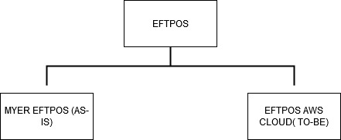



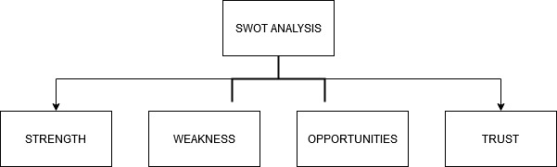

**4.** **Analysis:**

The analysis was been carried out using the SWOT method where all the strengths, weakness, opportunities and threats was been formulated. Based on the data that has been collected from various methods was found helpful to structure the SWOT analysis. Each and every component was been evaluated and the results was found using the analysis of AWS cloud migration of EFTPOS. Single time deployment process and dependencies of single database are found to be the weakness of it, whereas flexibility, reduction in lag time and enhanced application speed was found to be strengths of the migration technology.

**5. Findings:**

Better cloud for Application:

As per the data collected using various methods like observation method, questionnaire, focused group method of discussion, case study method, sampling the activity and these collected data was been analyzed using SWOT analysis and it was identified that, migrating the application to the AWS platform (cloud) was the better solution to overcome the existing drawbacks of the On Prem application by enhancing scalability, efficiency, budgeting with the limit.

Tools to build Application:

It was found that the tools that can be used to build the application includes Lambda, S3 bucket, Database, Load balancer etc.

**6. Recommendations:**

*What Is Amazon WorkSpaces? - Amazon WorkSpaces*. Docs.aws.amazon.com. (2020). Retrieved 24 November 2020, from https://docs.aws.amazon.com/workspaces/latest/adminguide/amazon-workspaces.html.

*Automate Amazon WorkSpaces with a Self-Service Portal | Amazon Web Services*. Amazon Web Services. (2020). Retrieved 24 November 2020, from <https://aws.amazon.com/blogs/desktop-and-application-streaming/automate-amazon-workspaces-with-a-self-service-portal/>.

*Amazon WorkSpaces Clients - Amazon WorkSpaces*. Docs.aws.amazon.com. (2020). Retrieved 24 November 2020, from <https://docs.aws.amazon.com/workspaces/latest/userguide/amazon-workspaces-clients.html>.

*Use Amazon CloudWatch Events with Amazon WorkSpaces and AWS Lambda for greater fleet visibility | Amazon Web Services*. Amazon Web Services. (2020). Retrieved 24 November 2020, from https://aws.amazon.com/blogs/desktop-and-application-streaming/use-amazon-cloudwatch-events-with-amazon-workspaces-and-aws-lambda-for-greater-fleet-visibility/.

**7. Conclusion:**

The above report discuss about the existing technology of Myer EFTPOS registers and its architecture. It also illustrates about the significance of migrating the application to the AWS cloud which provides better features than the on prem servers. The AWS architecture was also discussed within the report for clear understanding. The data was been collected from various methods which supports the fundamentals of application migration. The collected data was been analyzed using SWOT analysis which describes all the components of the AWS including strength, opportunities, weakness and threats of the cloud technology.

**References:**

MYER. (2020). Retrieved 14 October 2020, from <https://www.myer.com.au/content/about-us-myer/history>

Morris, A. (2016). Turn the Page: Why now is the time to migrate off Windows Server 2003. Retrieved from https://silo.tips/download/turn-the-page-why-now-is-the-time-to-migrate-off-windows-server-2003

Sutton, A. (2017). 2 Windows Server 2003 Structure and Architecture. Retrieved from <https://silo.tips/download/2-windows-server-2003-structure-and-architecture>

Mathew, S. (2020). Overview of Amazon Web Services.

Okumura, N., & Ogata, K. (2020). Formal analysis of RFC 8120 authentication protocol for HTTP under different assumptions. Retrieved from <https://www.sciencedirect.com/science/article/pii/S2214212619303722#bib0014>

Thomas, O. (2020). *Windows Server 2019 Inside out* (p. chapter 9).

Kumar, S., & Mall, A. (2017). Component Object Model: An Overview & Practical Implementation. Retrieved from <https://www.researchgate.net/publication/315066894_Component_Object_Model_An_Overview_Practical_Implementation>

Meng, M., & Steinhardt, S. (2018). Application Programming Interface Documentation: What Do Software Developers Want?. Retrieved from <https://www.researchgate.net/publication/318733467_Application_Programming_Interface_Documentation_What_Do_Software_Developers_Want>

AWS Global Accelerator - Amazon Web Services. (2020). Retrieved 10 November 2020, from <https://aws.amazon.com/global-accelerator/?blogs-global-accelerator.sort-by=item.additionalFields.createdDate&blogs-global-accelerator.sort-order=desc&aws-global-accelerator-wn.sort-by=item.additionalFields.postDateTime&aws-global-accelerator-wn.sort-order=desc>

Elastic Load Balancing - Amazon Web Services. (2020). Retrieved 10 November 2020, from <https://aws.amazon.com/elasticloadbalancing/?sc_channel=PS&sc_campaign=acquisition_AU&sc_publisher=google&sc_medium=load_balancing_b&sc_content=aws_load_balancer_e&sc_detail=aws%20load%20balancer&sc_category=load_balancing&sc_segment=159812791432&sc_matchtype=e&sc_country=AU&s_kwcid=AL!4422!3!159812791432!e!!g!!aws%20load%20balancer&ef_id=CjwKCAiAkan9BRAqEiwAP9X6UXKmV9ipS9qHUUSh49sUly2g1c6evpZ2hgRFA46eUEKYMH3xaTryIBoCq-IQAvD_BwE:G:s&s_kwcid=AL!4422!3!159812791432!e!!g!!aws%20load%20balancer>

Kurniadi, D. (2015). The Difference Between Using Proxy Server and VPN. Retrieved from <https://www.researchgate.net/publication/317809198_The_Difference_Between_Using_Proxy_Server_and_VPN>

Mukherjee, S. (2019). Benefits of AWS in Modern Cloud. Retrieved from <https://www.researchgate.net/publication/331586578_Benefits_of_AWS_in_Modern_Cloud>

Paradis, E., & O'Brien, B. (2016). Design: Selection of Data Collection Methods. Retrieved from https://www.jgme.org/doi/full/10.4300/JGME-D-16-00098.1

Sajjad Kabir, S. (2016). METHODS OF DATA COLLECTION. Retrieved from <https://www.researchgate.net/publication/325846997_METHODS_OF_DATA_COLLECTION>

Lepenioti, K., & Bousdekis, A. (2019). Prescriptive Analytics: A Survey of Approaches and Methods: BIS 2018 International Workshops, Berlin, Germany, July 18–20, 2018, Revised Papers. doi: 10.1007/978-3-030-04849-5_39

GÜREL, E. (2017). SWOT ANALYSIS: A THEORETICAL REVIEW. doi: 10.17719/jisr.2017.1832